Functional Requirements Document – Customer Service

Prepared for
Technica

Version: 3.0

Prepared by:
Nermine Boulos

Contributor:
Abdo Khoury

Table of Content
Contents
Introduction 3
1.1 Purpose 3
1.2 Acronyms 3
1.3 General 4
Business Processes List 5
1.1 Processes List 5
Business Processes 6
1.1 CS001 Claims Registration 6
1.1.1 To-be Process 6
1.1.2 Requirements 13
1.2 CS002 Snag Registration 14
1.2.1 To-be Process 14
1.2.2 Requirements 18
1.3 CS003 Surveys Creation 19
1.3.1 To-be process 19
1.3.2 Requirements 19
Knowledge Articles 20
2.1 Create Knowledge Articles 20
2.2 Mark a knowledge article for review 22
Entitlements 23
Reporting, Charts & Dashboards 24

Introduction
  - Purpose
The Functional Requirements Document (FRD) describes in common terms:
- An overview of the processes comprising each Work stream
- An overview of each sub-process comprising the Work stream
- Major gaps between the business requirements and the functionality supported by the standard Microsoft Dynamics 365 solution
- The problem summary including current business/environment issues
- Proposed technology to support the new or altered business processes
- How implementation of the proposed solution will benefit the users/stakeholders

The FRD is the starting point of the solution and system development and is a collaborative effort between all business and technology stakeholders. The purpose of the Functional Requirements Document (FRD) is to document requirements for the requested system solution.
The objective of the Functional Requirements Document is to provide enhanced documentation for requirements that are a gap or will require a workaround or process change in order to fit the system solution of the client. The need for any modifications is clarified through the FRD. The FRD forms the basis of the subsequent task concerning the system design.
This document focuses on Customer Service requirements.
  - Acronyms
Abbreviation | Explanation
FRD | Functional Requirement Document
System | Dynamics 365
OOB | Out of the box
CRM | Customer Relationship Management System
CS | Customer Service
F&O | Finance and Operations

  - General
Technica’s Customer Service Process takes into consideration claims, snags and the project installation till commissioning and handing over that is handled under resource allocation section in the Project FRD. Claims are cases submitted/reported by customers after the project’s closing. Whereas Snags are reported by engineers during any project phase.
This document will handle the roles of the Customer Service team and their managers.
Approval cycles for HOD can be added later on if needed at any stage of the claims/snags process.

Business Processes List
  - Processes List

In order to elaborate and define the functionality, the following processes have been presented in the subsequent sections:

Process ID | Name | Description
CS001 | Claims Registration | Register Claims manually/automatically (through email)
CS002 | Snag Registration | Register reported snags
CS003 | Survey Creation | Create surveys for customer satisfaction

Business Processes
  - CS001 Claims Registration

To-be Process
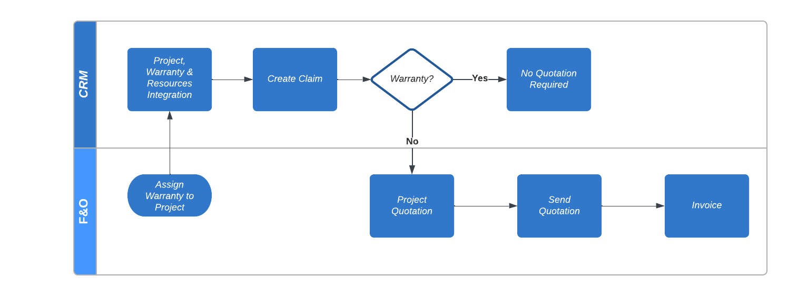

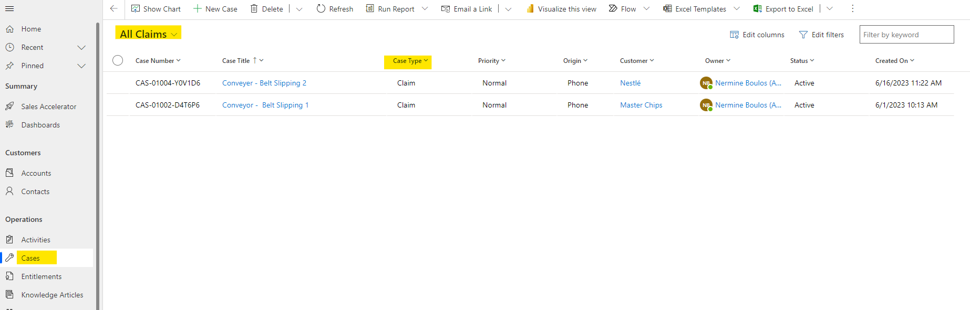

      - Creating Case of Type Claims
- CS engineer will create a case of type claim, and will fill all claim related info in the identify stage. The claim will always be attached to a project, a customer, and an assembly. Noting that the project is integrated from F&O
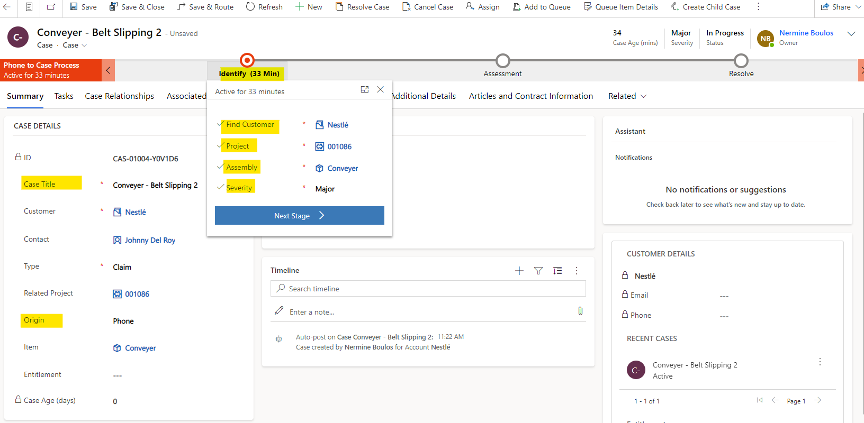
- Upon saving, CS engineer will be allowed to move to the next stage (Assessment Stage)
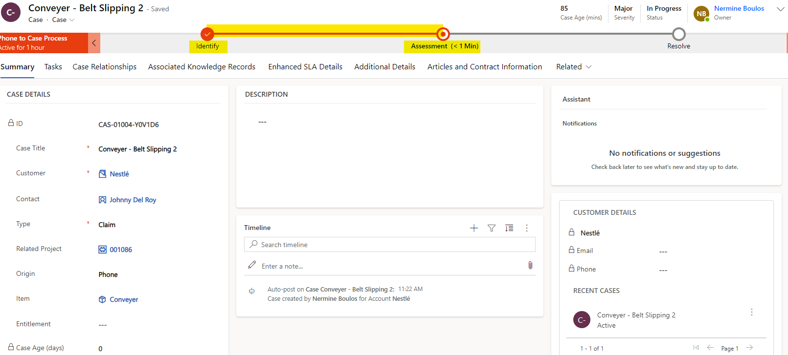

Same process will be applied if the claim is automatically created from email. On D365 you can setup Automatic Record Creation and Update rules (OOB feature) to automate the process of case creation from received emails. Furthermore, if you want to convert manually an email into a case, it also an out-of-box feature that you can use from Outlook. The goal is straightforward: A new email contains information regarding a new issue that needs to be tracked in Dynamics 365.
When you decide that an email needs to be linked to a new case in Dynamics 365, you can do so using the Dynamics 365 Add-in in Outlook:
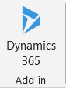
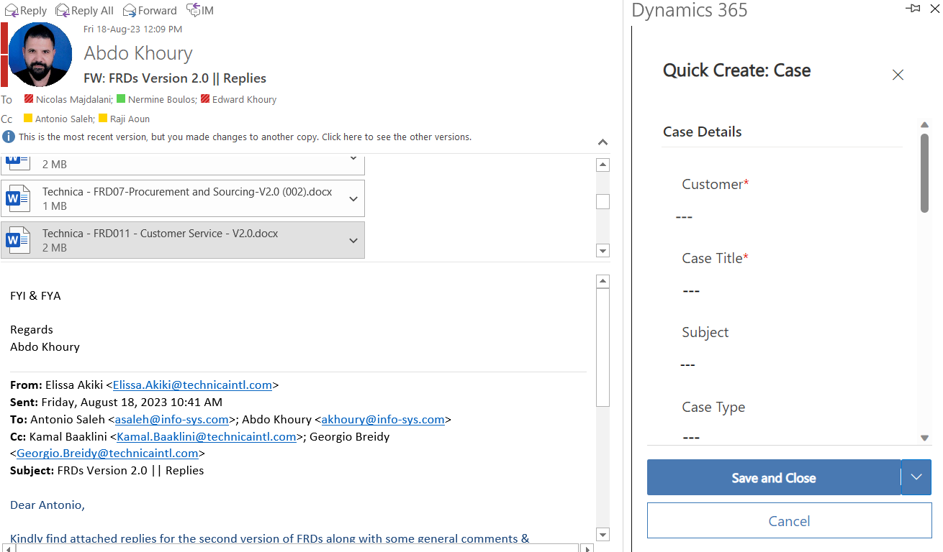

To make the process even faster, if the email sender already exists in Dynamics 365, some of the fields are pre-populated for you. The app fills in the Customer field with the recipient’s account name and the Case Title field with the email subject, and assigns you as the owner of the case. From here, all you have to do is to click Save and the case is immediately created in Dynamics 365 with the email linked to it.

      - Claim Assessment & Create Activities
- Once claim is in the assessment stage, customer service engineer can collect additional info from customer through phone calls that can be registered on the case’s timeline.
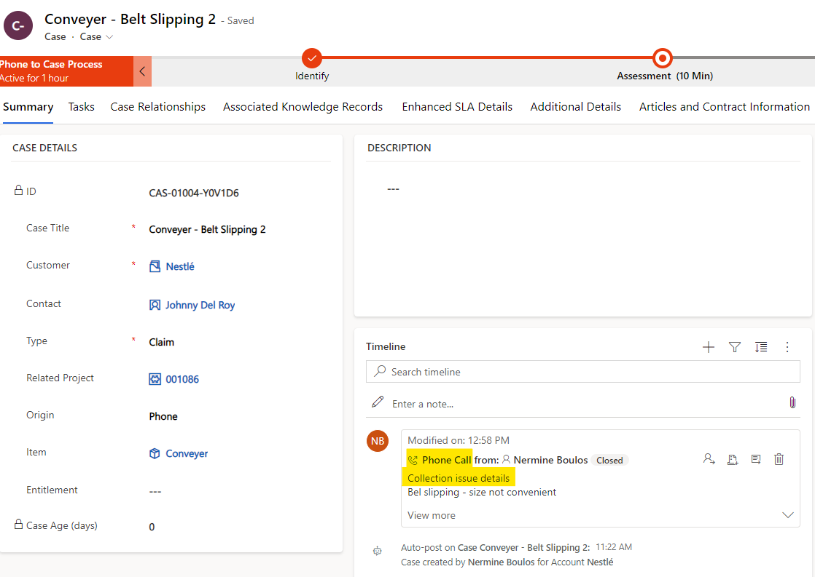
- When the claim is clarified, the CS agent will be able to fill claim description, add activities and assign corresponding engineers including himself.
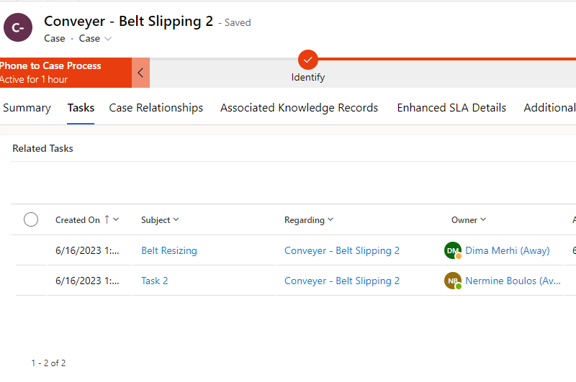
- Assigned engineer will receive an email notification with the task assigned to him.
- Assigned engineer must fill his timesheet against his assigned tasks.
  - All timesheets registered on CRM will be then pushed to F&O.
  - Timesheets can be registered on system and from mobile when on site.
  - Timesheets will have a field for overtime hours
  - Total hours and total overtime hours of registered timesheets will be visible on case level
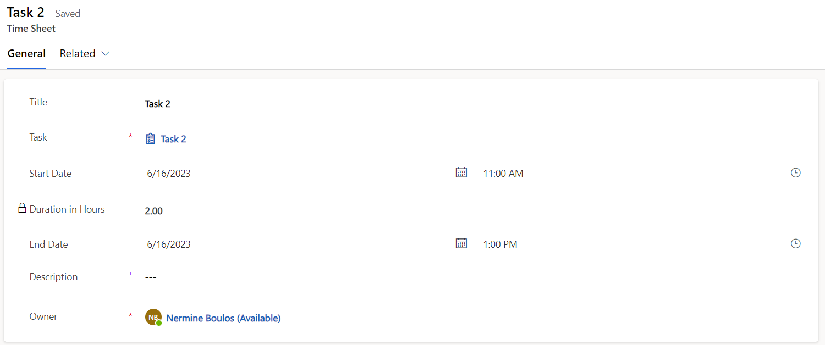
- When task is done, the assigned engineer must mark the task as complete.
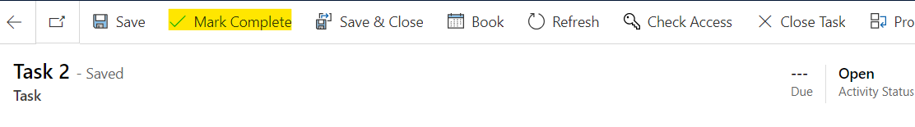
- After all tasks are completed, engineer will proceed to the last stage.
      - Resolving Claim
- CS engineer will make sure to resolve the case and add the resolution details.
- Upon resolution, email will be sent to the concerned resource for quotation preparation. Automatic quotation creation on F&O upon resolution is feasible if need in addition to quotation lines including parts and time cost.
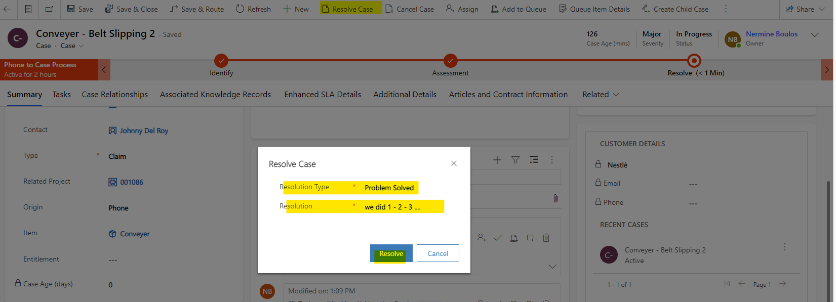

- The case will be read-only but can be re-opened if needed.
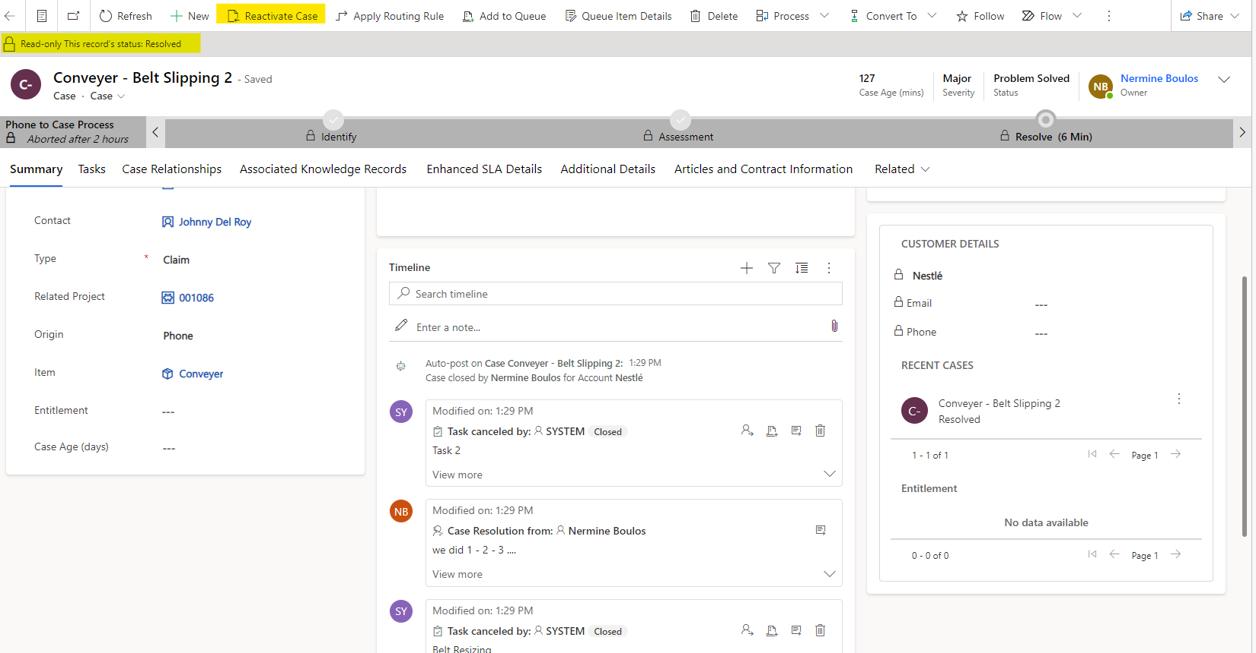
- Case re-opening is registered in the timeline control
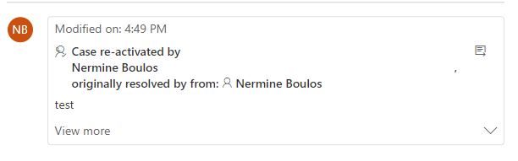

Requirements
ID | Desc | Fit/GAP
CS001-001 | Create Case Manually | Fit
CS001-002 | Create Case Automatically from email | Fit
CS001-003 | Assign Cases | Fit
CS001-004 | Create & Assign Tasks | Fit
CS001-005 | Automate email notification upon assignment | GAP
CS001-006 | Resolve Case | Fit
CS001-007 | Ability to Re-open Case | Fit
CS001-008 | Ability to Register Timesheets | GAP
CS001-009 | Overtime calculation automation and setup | GAP
CS001-010 | Register Warranties and warranty validation upon claim registration | GAP
CS001-011 | Automatic F&O Quotation Creation upon case resolution | GAP

  - CS002 Snag Registration

To-be Process

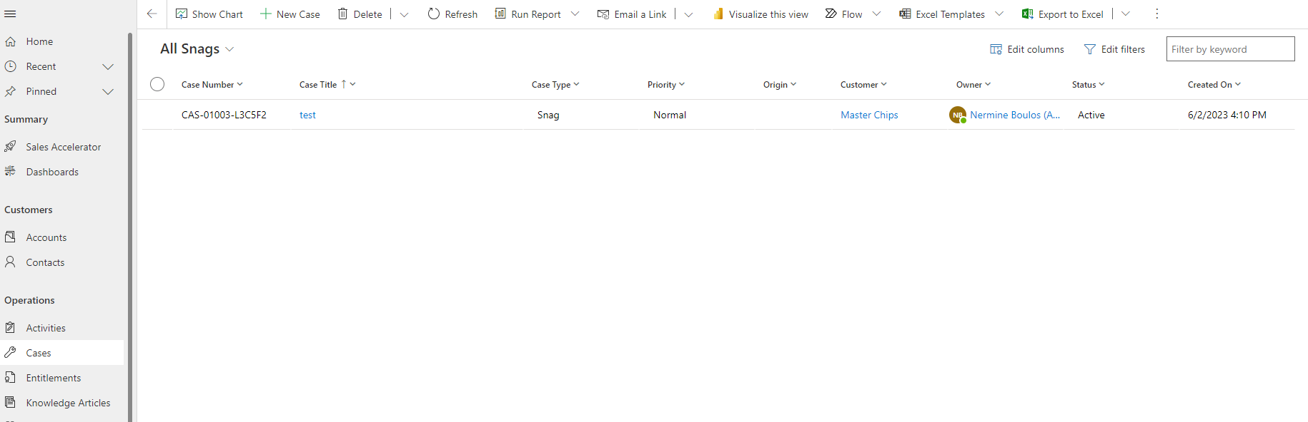

      - Creating Snags
- Snags are created manually or can be imported from an excel sheet.
- Site manager is the one who creates the snags captured on site
- Snags are captured during installation and commissioning on site
- Whenever w snag is detected before shipping, it’s categorized as revision
- Snags are registered against a customer, a project and a specific assembly
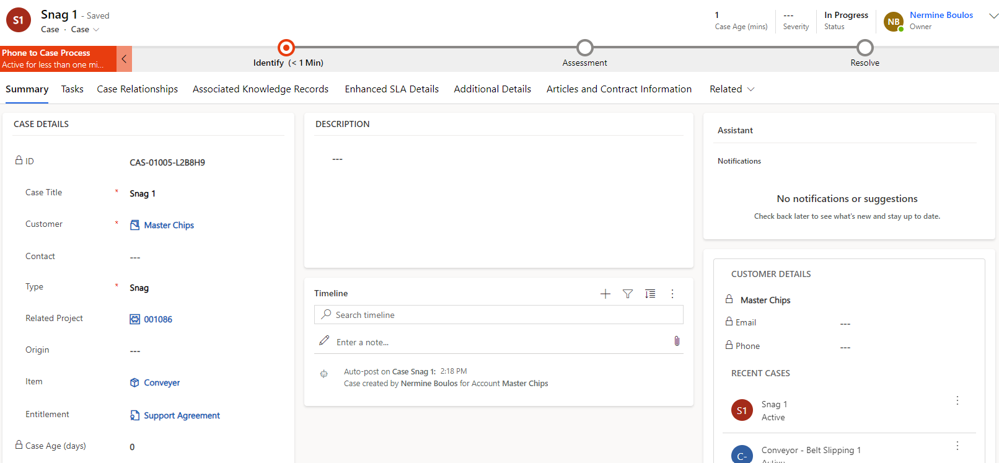
- After snag identification, site manager can move to the next stage (Assessment) in which project manager will be assigned to the created snag to complete the snag process until resolved.
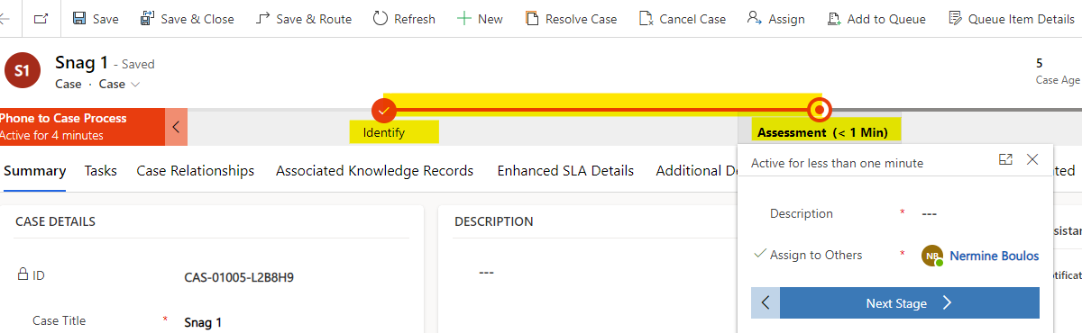

      - Snag Assessment
- Project manager receives an email notification that he has been assigned to a snag
- Project manager will be responsible in the assessment stage. Where he will create tasks and assign them to corresponding engineers.
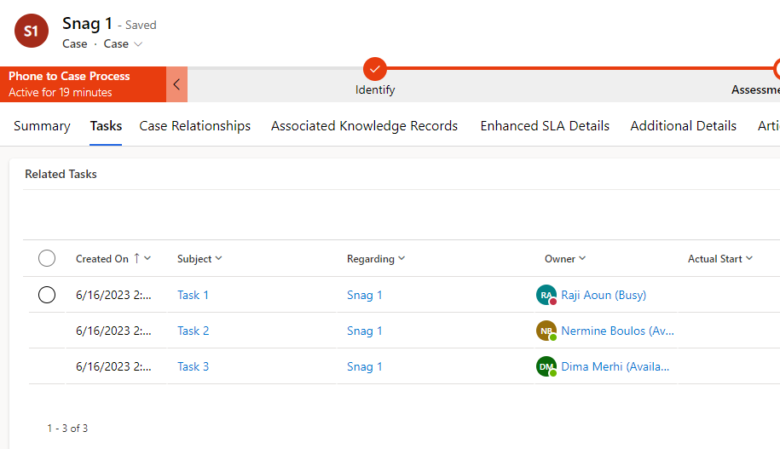
      - Timesheet Registrations & Task Completion
- Engineers will receive a notification when task is assigned
- Engineer should fill his timesheet against his assigned task.
  - All timesheets registered on CRM will be then pushed to F&O.
  - Timesheets can be registered on system and from mobile when on site.
  - Timesheets will have a field for overtime hours
  - Total hours and total overtime hours of registered timesheets will be visible on case level
- When task is done, the assigned engineer must mark the task as complete.

      - Snag Resolution
- When all tasks are completed, project manager can resolve the case
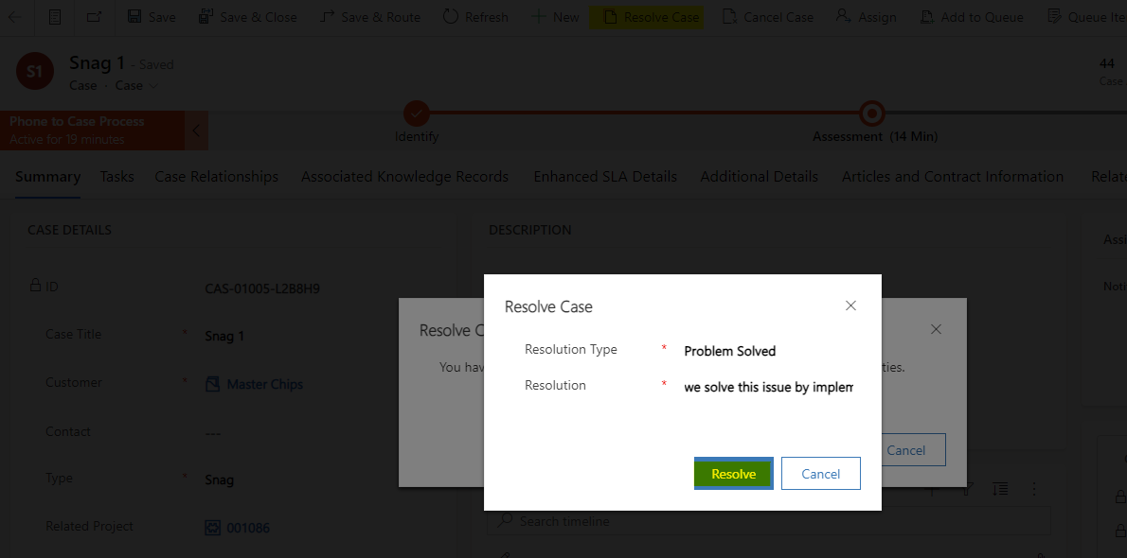
- Snag can be re-activated in case of any missing info or adjustments
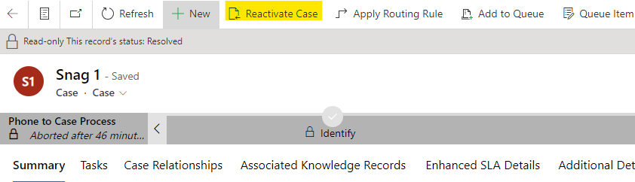

Requirements
ID | Desc | Fit/GAP
CS002-001 | Create Case Manually | Fit
CS002-002 | Create Case Automatically from email | Fit
CS002-003 | Assign Cases | Fit
CS002-004 | Create & Assign Tasks | Fit
CS002-005 | Automate email notification upon assignment | GAP
CS002-006 | Resolve Case | Fit
CS002-007 | Ability to Re-open Case | Fit
CS002-008 | Ability to Register Timesheets | GAP

  - CS003 Surveys Creation

1.3.1 To-be process
Here you will simply have to design once and for all your customer satisfaction survey and setup survey configuration. You can go back to it and edit it anytime, so the process will be as follows:

- Sending survey can be automated. For example, upon claim resolution.

Requirements
ID | Desc | Fit/GAP
CS003-001 | Create Surveys | Fit
CS003-002 | Sending Surveys Automation | GAP

Survey Designing is an application by itself called Voice of the Customer. Creating a survey and designing it is OOB. However, to automate the sending of the survey requires flow development.
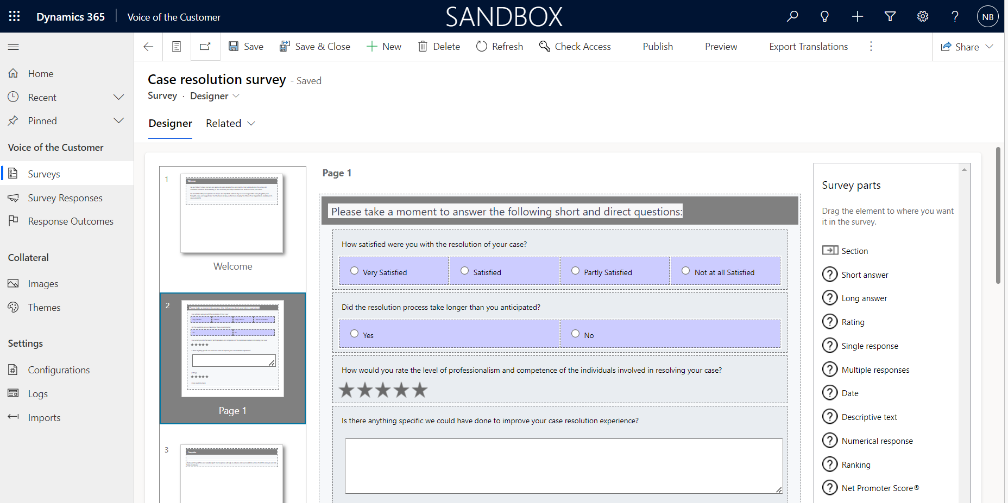

Knowledge Articles
Turn your customer questions, issues, and feedback into knowledge articles, so that agents can benefit from them. Add images and videos to your articles to explain things better and make the articles engaging. You can author, edit, search, publish, and translate the knowledge articles.
Types of knowledge articles can include solutions to common issues, product or feature documentation, answers to frequently asked questions (FAQ), product briefs, and more.
  - Create Knowledge Articles
- Go to Knowledge Articles.
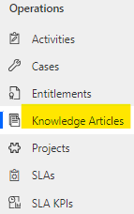
- On the command bar, select New.
You’ll be on the Content tab of the knowledge article.

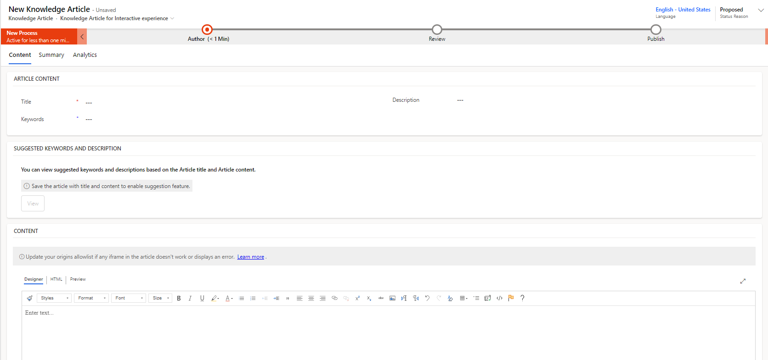

- In the Article Content section, fill in the following details:

- Title: Type a descriptive title that communicates the subject and purpose of the article in a concise manner.

- Keywords: Type or select keywords for the article. These keywords are used to search the knowledge base for articles. Separate keywords with commas.

- Description: Type or select a short description of the article. This appears in the search results and is used for search engine optimization.

- In the Content section, add the content for your knowledge article.
- Select Save.
- As the article is saved, the Business Process flow bar appears for the article. The stages are New Process, Author, Review, and Publish. The Business Process flow bar guides you to drive the article toward completeness. You can customize the stages in the Business Process flow to suit your requirements.
- On the Business Process flow bar, select Author.
- In the Set Keywords text box, add keywords for your article.
- In the Article Subject dropdown list, choose the subject of the article to help with article searches.
- In the Assign Primary Author dropdown list, choose a person who is responsible for maintaining the article content. By default, the user who creates the article is the primary author.
- Once a new article is created, the author value will be replicated to Primary author if it is a system user but not a team. The knowledge article author must be a single user (not a team) in order for it to be searchable and to load properly.
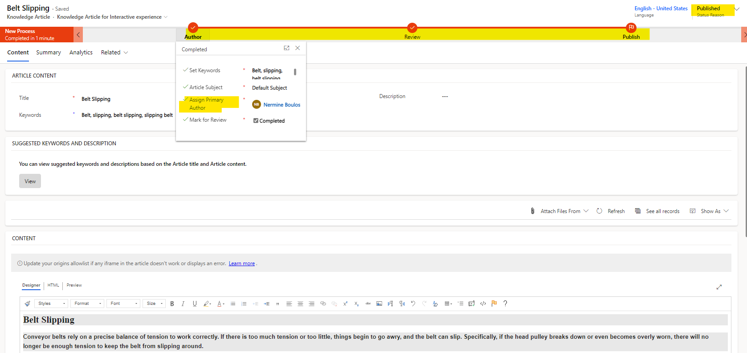
- You can mark the article complete by selecting the checkbox at this stage.
  - Mark a knowledge article for review
To ensure that the content you’ve created is accurate, have someone review it.
You can mark an article for review or directly assign it to a specific person or queue. When you mark an article for review, it starts appearing in the knowledge manager’s dashboard. The knowledge manager can then assign the article to specific team members or a queue for review.
- In the article you want to mark for review, in the Status Reason dropdown list, select Needs Review.
- On the Business process flow, select Author.
- In the Mark for Review field, select Mark Complete.
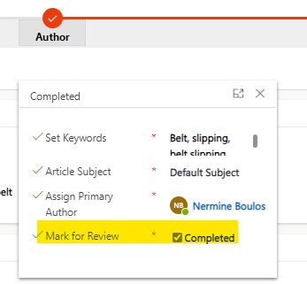
- Knowledge article review.
- To assign the knowledge article to another reviewer or team, on the command bar, select Assign and select the user or a team.
- To add the article to a queue so reviewers can pick it from there, on the command bar, select Add to Queue, and then select the queue.

Entitlements
Define what kind of support your customers are eligible for by creating entitlements in Dynamics 365 Customer Service. With entitlements, you specify the support term based on number of hours or number of cases. The customer’s support level can vary based on the product or service that the customer has purchased. Customers who’ve purchased different products can be entitled to different support levels. This information helps the customer support agents verify what the customers are eligible for and create cases for them accordingly.
- Entitlements are created as Maintenance contracts with specific number of cases of type visit
- Entitlement can be activated, deactivated, renewed
- Entitlement can be set as default, in other words if a customer has an entitlement set as default, when a case is created for the customer, the case is automatically linked to the entitlement
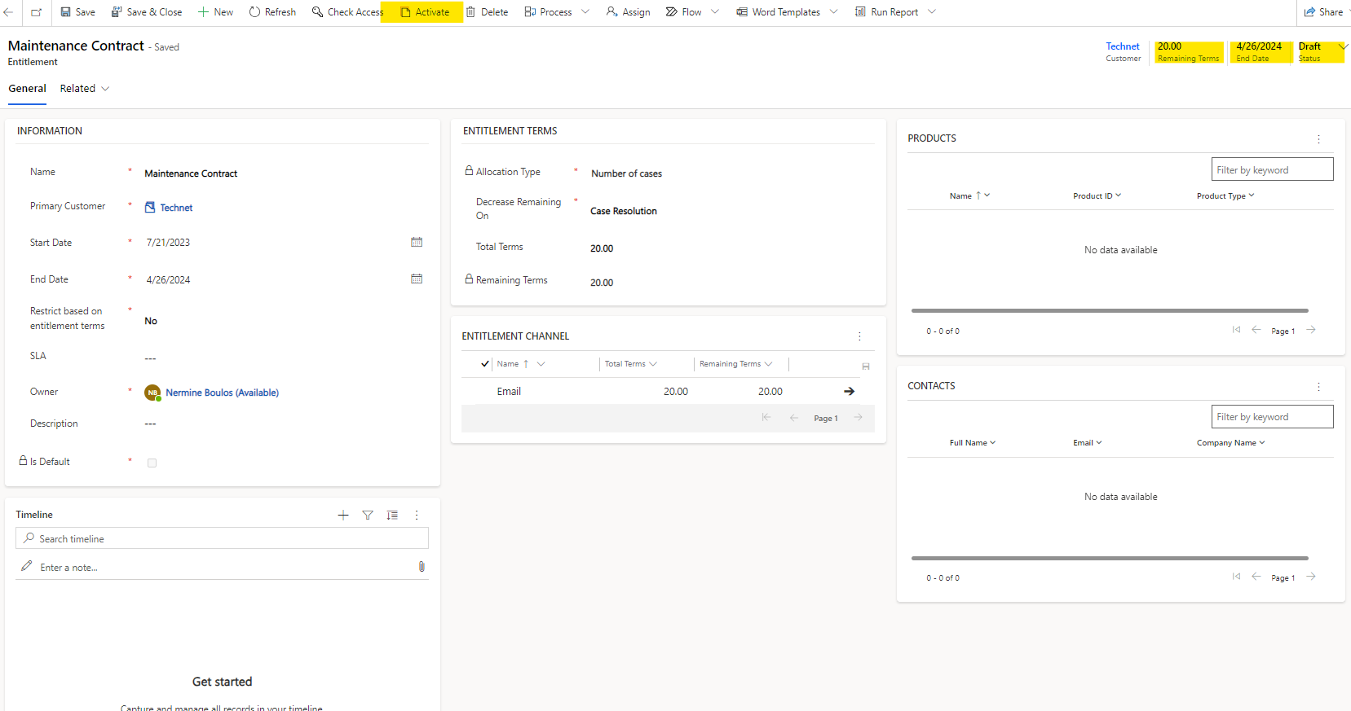
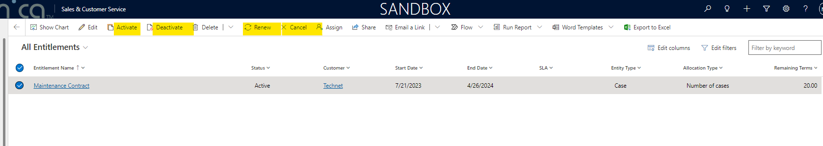

Reporting, Charts & Dashboards
The System contains a number of reports, charts and dashboards that are OOB.

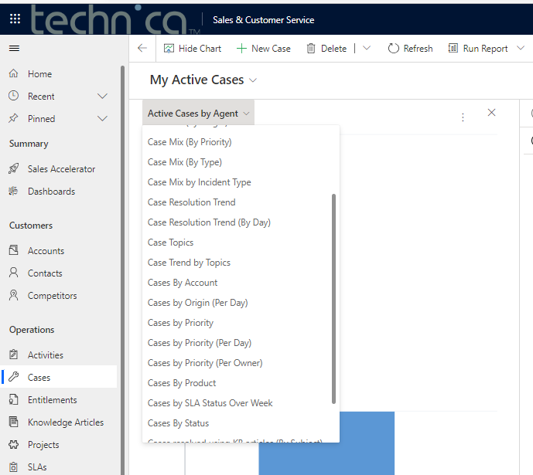
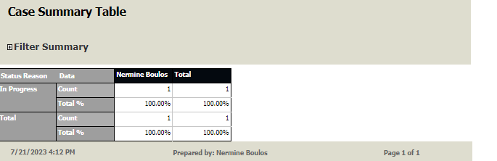
Mainly needed reports will be defined Technica. Note that reports, dashboard & charts can be pre-defined and done in the backend yet D365 allows users to customize their own reports, charts and dashboards. Reports, charts and dashboards customization can be given later on during the training.

DOCUMENT APPROVALS
I have reviewed the information contained in this document and approved it through by sign off below:

Name | Department | Date | Signature

Comments:
Any dashboard possibility, (maybe shown during the meeting?), for the number of online, closed and pending claims/ snags, overall and per project? There are already OOB reports and charts existing that I added to the sections. However mainly needed reports should be specified from your side and included in the FRD. For ex. Count of Claims by customer/project. I added a section for reporting. Feel free to add the reports you want to include in the scope so later on we can discuss requirements.
how the time reported by Site leader will be imported to the system? (DSR)? not mentioned in the file or during the meeting. Resources will fill the time sheets on system based on allocated tasks : Samer :daily site reports are filled by site leaders and sent to head office to register the travel days for each resource , this section should be clarified as it’s very important to clarify: timesheet may be registered on installation (on a specific activity in the WBS) on F&O
Or may be registered against tasks that are under a snag/claim which are linked to a project and/or an assembly. Timesheets will have a field to flag travel or no (it influences later on the payroll). Time sheets will be integrated to F&O
What about Services/ client paid visit / AMC (annual maintenance contract): going to be treated as mini project? Then After sales manager and spare parts team should be able to create projects, not only sales/sales support Annual maintenance Contracts are entitlements that can be renewed. Client pail visit is a case type. Samer :sample case to be discussed in a meeting for review – AMC are treated as mini projects , still didn’t get the answer how to deal with them . AMC are linked to a specific project (optional), each contract must have a set of activities to be scheduled ahead of time. These activities can be assigned to team members (reminders and calendars): So AMC will be registered on F&O as Project in order handle the accounting part (Please refer to project FRD) and since projects are integrated in CRM as mentioned before, AMC operations will be handled in CRM by creating Cases and Activities that can be scheduled ahead of time on which resources are assigned and timesheets are registered.
The specifications and conditions are hereby accepted. Info-Sys is authorized to execute the project as outlined in this document. This document is not valid until signed by the customer representative and returned to Info-Sys.

Signature: __________________________________ Date: _________________________________

